
WORK FROM HOME LLC
Get Ready to Take Control of your Life
Follow the following Steps to get started
Go to www.arise.com
Click on Find Work

Click on Register Now

Create your account to login
Select your State and Consent to agreement. Click Create Account
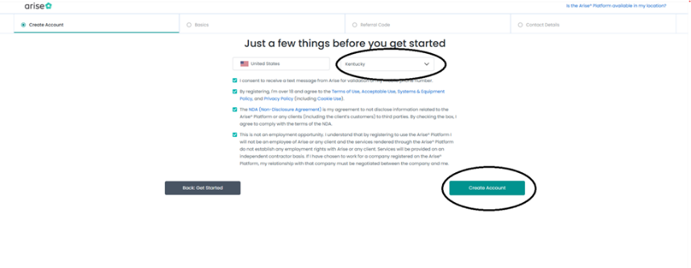

Enter your Info about yourself. (add all languages you speak) We hire for multiple languages. Click Referral code
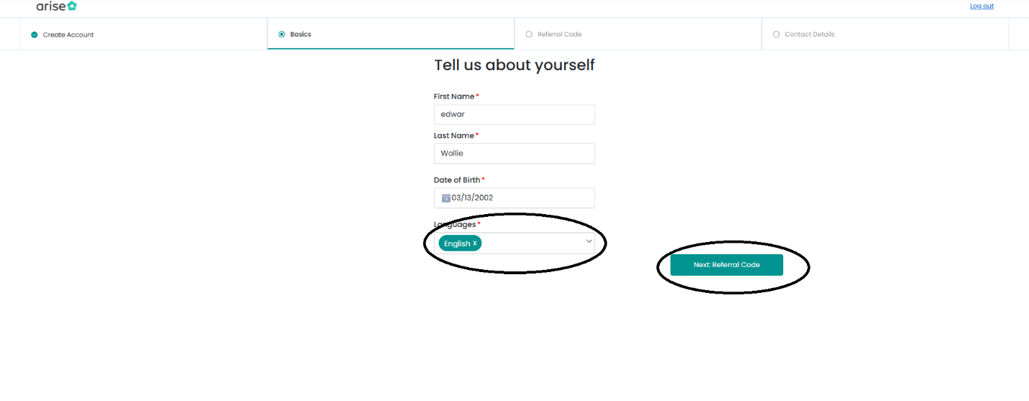
Click (I don’t have a referral code) the click Next: Contact Details
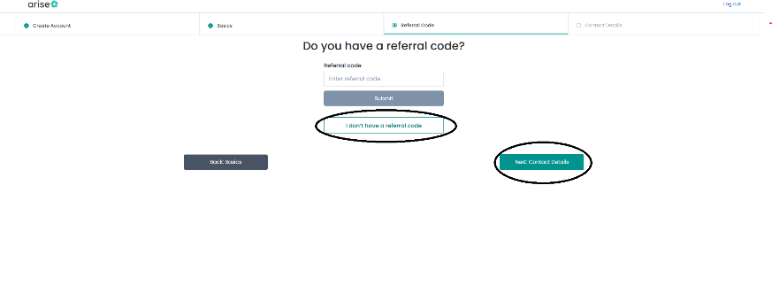
Enter your contact Information and click Next
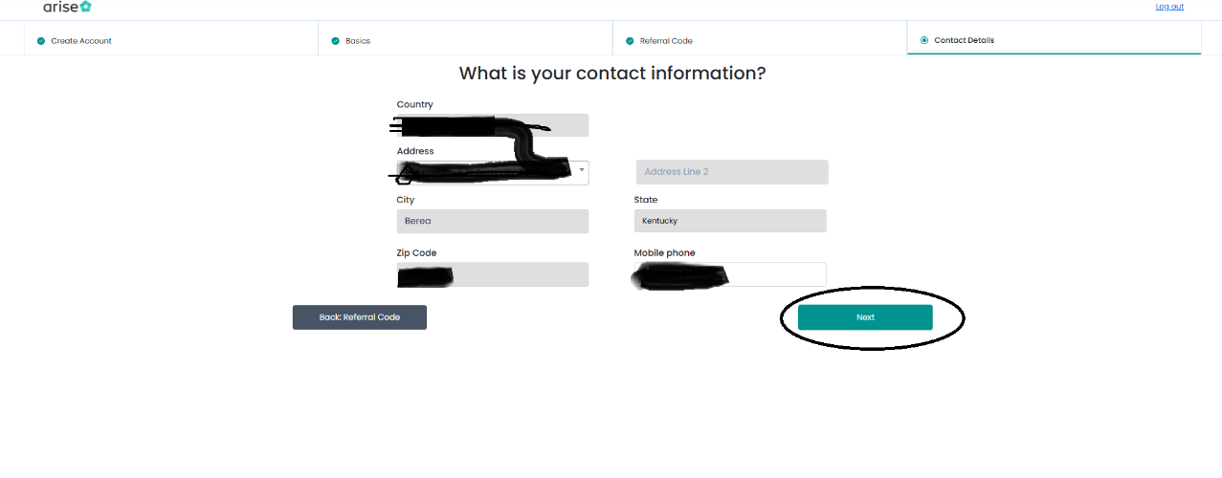
Run PC Scan. This will determine if your PC is ready for work. (Contact ME if your SCAN FAILS) You can SKIP it if you think your PC is not ready. Of if you’re not working on your service PC
Please make sure you have 45 minutes to an hour to complete this assessment and are in a quiet area. NOTE: If you do not pass this assessment, you cannot complete the registration.
Click BEGIN ASSESSMENT (A new page will open) Consent by clicking the Checkbox and click CONTINUE.
For Fairness, you will be monitored during the Assessment.
Once Assessment is completed, Close the Assessment Tab (NOT THE WEBPAGE) and then click REFRESH on the Registration page.
This will Take you to the next page with a short Video. You can choose to watch the video and answer the question, or you can click NEXT.
Click VIEW OPPORTUNITIES on the popup screen
Click FINISH REGISTRATION
Click I want to WORK FOR SOMEONE ELSE. (This allows you to join us as an agent. If you Click Be My Own Boss, you will have to have a company or business to register with Arise.)
Click JOIN A SERVICE PARTNER
ENTER YOUR INFORMATION AND CLICK NEXT
Search for our Company using our FEIN (41-2378799) and click SEARCH
Our business name will popup Work From Home LLC Click NEXT

PLEASE CONTACT ME ONCE YOU HAVE COMPLETED THE STEPS TO INFORM ME OF PENDING REQUEST.
I WILL REACH OUT TO YOU ONCE YOUR REQUEST HAS BEEN SENT WITHING 10 MINUTES OF YOUR REQUEST.
Email: workfromhomellc1@gmail.com
Phone: 859-302-1214

